To: | City Executive Board
Date: | 22 January 2019
Report of: | Head of Financial Services
Title of Report: | Treasury Management Mid-Year Review for April – September 2018

Summary and recommendations
Purpose of report: |  | To report on the performance of the Treasury Management function for the 6 months to 30th September 2018
Key decision: |  | No
Executive Board Member: |  | Councillor Ed Turner, (Deputy Leader) Finance, Asset Management and Public Health
Corporate Priority: |  | None
Policy Framework: |  | Efficient and effective Council
Recommendation:That the City Executive Board resolves to:
1. | Note the performance of the Treasury Management function for the six months to 30th September 2018.

Appendices
Appendix 1 | List of investments as at 30th September 2018
Appendix 2 | Risk Register

Introduction and Background
- This report has been written in accordance with the requirements of the Chartered Institute of Public Finance and Accountancy’s (CIPFA) Code of Practice on Treasury and has been prepared in compliance with CIPFA’s Code of Practice on Treasury Management, covering the following:
- An economic overview for the first part of the 2018/19 financial year
- A review of the Council’s investment portfolio for 2018/19
- A review of the Council’s borrowing strategy for 2018/19
- A statement of compliance with Treasury and Prudential Limits for 2018/19
- The Council operates a balanced budget, which broadly means cash raised during the year will meet its cash expenditure. Part of the treasury management operations ensure this cash flow is adequately planned, with surplus monies being invested in low risk counterparties, providing adequate liquidity initially before considering optimising investment return.
- The second main function of the treasury management service is the funding of the Council’s capital plans. These capital plans provide a guide to the borrowing need of the Council, essentially the longer term cash flow planning to ensure the Council can meet its capital spending operations. This management of longer term cash may involve arranging long or short term loans, or using longer term cash flow surpluses, and on occasion any debt previously drawn may be restructured to meet Council risk or cost objectives.

Economic Overview
- The first half of 2018/19 has seen a modest growth in the UK economy, but sufficiently robust enough for the Monetary Policy Committee, (MPC) to unanimously (9-0) vote to increase Bank Rate on 2nd August from 0.5% to 0.75%. Although growth looks as if it will only be modest at around 1.5% in 2018, the Bank of England’s August Quarterly Inflation Report forecast that growth will pick up to 1.8% in 2019, but much of this is dependent on an orderly withdrawal from the European Union in March 2019.
- Some MPC members have expressed concerns about a build-up of inflationary pressures, particularly with the pound falling in value again against both the US dollar and the Euro. The Consumer Price Index (CPI) measure of inflation rose unexpectedly from 2.4% in June to 2.7% in August due to increases in volatile components, but is expected to fall back to the 2% inflation target over the next two years given a scenario of minimal increases in Bank Rate. The MPC has indicated Bank Rate would need to be in the region of 1.5% by March 2021 for inflation to stay on track. Financial markets are currently pricing in the next increase in Bank Rate for the second half of 2019.
- Unemployment has continued at a rate of 4% on the Independent Labour Organisation measure. A combination of job vacancies hitting an all-time high in July, together with negligible growth in total employment numbers, indicates that employers are now having major difficulties filling job vacancies with suitable staff. It was therefore unsurprising that wage inflation picked up to 2.9%, (3 month average regular pay, excluding bonuses) and to a one month figure in July of 3.1%. This meant that in real terms, earnings grew by about 0.4% (i.e. wage rate rises are higher than CPI inflation), near to the highest of 0.5% since 2009. (The previous high point was in July 2015.)

Interest and Interest Rate Forecasts
- The performance target rate for investment returns is 0.6% above base rate, equating to 1.1% from April until the beginning of August when the MPC voted unanimously to increase base rate by 0.25%, thereby proportionately increasing the Council’s target rate to 1.35%. The cumulative average rate of return on investments to 30th September 2017 was 1.13%, which is 0.22% below the performance target of 1.35%.
- The base rate rises in November 2017 and August 2018 have resulted in the Council not always exceeding its target rate of return which is 0.6% above base; this is due to the fact that the majority of the Council’s investments are held in fixed deposits and therefore, any investments arranged prior to November 2017 and those arranged between November 2017 and August 2018 did not benefit from the subsequent rises. This is a risk of which the Council is aware and seeks to manage by establishing an evenly distributed maturity profile where possible. However, given the volatile nature of cashflow, cash balances fluctuate throughout the year and it is important to maintain a liquid position so that financial obligations are met as and when they fall due. There have been and continue to be some uncertainty in the timing of some significant financial transactions (such as the sale of the Council’s land at Oxpens and the purchase of properties at Barton). To that end, the Council also holds a proportion of cash in instant access deposit facilities such as call accounts and money market funds. The inclusion of instant access cash instruments within the investment portfolio provides some advantage in as much as there is an instant benefit from any rate rises and availability of cash to meet expenditure of uncertain timing, however the downside to short deposits is that the interest rate will always produce a lower yield than longer term investments.
- The MPC intimated once again that future bank rate increases will be gradual and would rise more steadily than before the 2008 crash, indicating that base rate will not reach 2.5% for another ten years, although they did not produce a medium term forecast.
- The Council’s Treasury advisers, Link Asset Services, do not think that the MPC will further increase base rate until August 2019, although much is dependent on the final Brexit deal for the UK’s departure from the European Union in March 2019.
- Currently, Link Asset Services interest rate forecast is as follows:
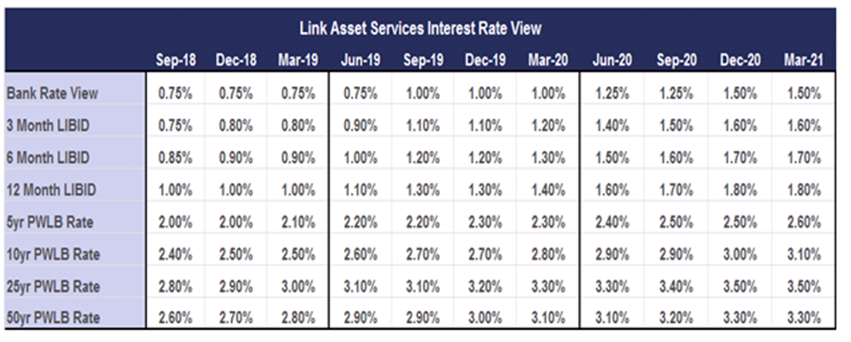

Investment Portfolio and Performance
- The budgeted investment income for 2017/18 is £1.839 million. As at the 30th September 2018, forecast investment income for 2018/19 is £1.814m. There are a number of reasons for the variation but the primary impact is reduced net interest from the Council’s companies due to expected slippage in their capital expenditure plans.
- The Treasury Management Strategy for 2018/19 was approved by this Council in February 2018; to date the Strategy has been fully adhered to and there are no proposed changes at this stage.
- As part of its Strategy, the Council aims to maintain a diversified investment portfolio whilst ensuring there are no policy and procedure breaches. Security of investments is always the primary concern when arranging investments with liquidity and yield being secondary, but key considerations.
- The Council operates an approved counterparty listing which details all institutions with whom the Council may invest, the maximum amount which may be invested with any single counterparty group at any given point and the maximum duration period. The counterparty list is set in association with recommendations from Link Asset Services although ultimate authorisation of approved counterparties rests with the Section 151 Officer. The list is actively managed and reviewed on a weekly basis or more regularly if required.
- The strategy also adopts an ethical approach to investments, stating that:
“The Council will not knowingly invest directly in businesses whose activities and practices pose a risk of serious harm to individuals or groups, or whose activities are inconsistent with the Council’s mission and values. This would include, inter alia, avoiding direct investment in institutions with material links to:
- Human rights abuse (e.g. child labour, political oppression)
- Environmentally harmful activities (e.g. pollutants, destruction of habitat, fossil fuels)
- Socially harmful activities (e.g. tobacco, gambling)”
- Over the past quarter, there appears to be more awareness of ethical investments in the market with more counterparties introducing their own ethical policy and in some cases, establishing “green deposit” products into which customers may invest.
- The Council has been able to take advantage of some green deposit notice accounts offered by Barclays Bank who are working in association with Sustainanalytics, a leading global provider of environmental, social and corporate governance research and ratings, to achieve a positive environmental impact. Their green framework covers the following environmental areas:
- Energy efficiency projects and renewable energy
- Sustainable food agriculture and forestry
- Waste management
- Greenhouse gas emission reduction
- Sustainable water
- Initial deposits into the green deposits were placed in October 2018 and therefore, more detailed information regarding their performance will be included in the Treasury outturn report.
- Concerns have been raised over Barclays’ funding of three pipelines to link Canada’s Alberta province with the country’s Pacific coast and the US which are connected with “tar sands” operations. The Council has written to Barclays to express its concerns over this and is awaiting a response.
- In May 2018, Council agreed to extend its existing loan facility to Low Carbon Hub. In 2013, the Council set up a loan facility for the value of £1.623m. Of this capital sum, £1.3m remained payable as at 30th September 2018, but interest is charged at an annual rate of 5% and collected on a monthly basis. The Financial Accounting team is in regular contact with Low Carbon Hub and they have repaid the loan in November 2018.
- The chart below illustrates the Council’s performance against its benchmarks and also tracks inflation rates, thereby showing the Council’s return in “real terms”. It is also important to note that the Council’s return – the Weighted Average Rate of Return (WARoR) – is significantly boosted by the Council’s investments in property funds and that without these the Council would not achieve its target rate.
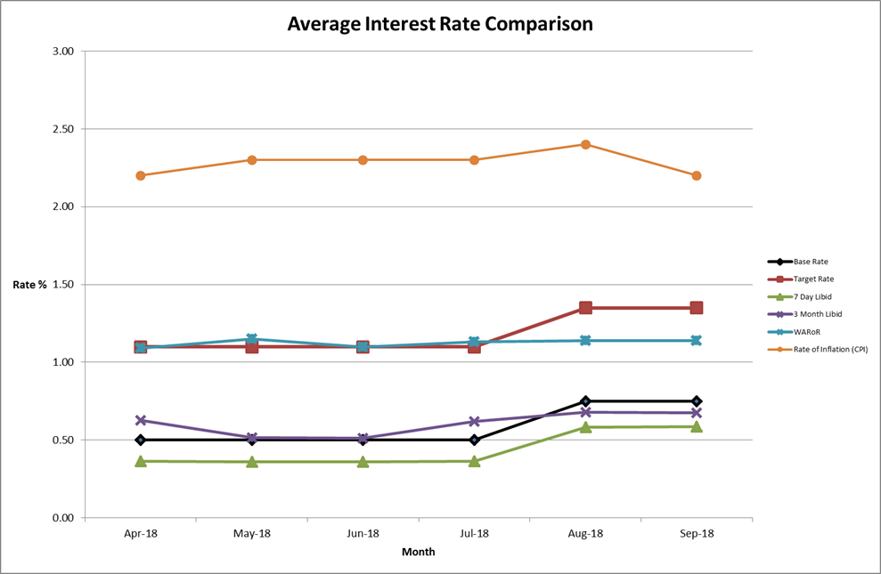

Property Funds
- At present, the Council has placed investments with two property funds; CCLA Investment Management, which is a property fund that limits its investors to Charities, Churches and Local Authorities and Lothbury Investment Management, a specialist UK property fund manager with a range of funds providing high quality exposure to different property sectors.
CCLA Investment Management Limited
- The Council has held a £3m investment in the CCLA fund since September 2013. The investment has produced quarterly returns ranging between 5% and 6% and it is expected that the Fund will continue to achieve rates in this region.
- Additionally, the value of the Council’s investment with CCLA has appreciated from £3m to £3.86m as at 30th September 2018, equating to growth of 28.92% to date. However, the values of the individual unit prices have fluctuated over time and the effect of capital appreciation (and depreciation) is illustrated in the graph below.
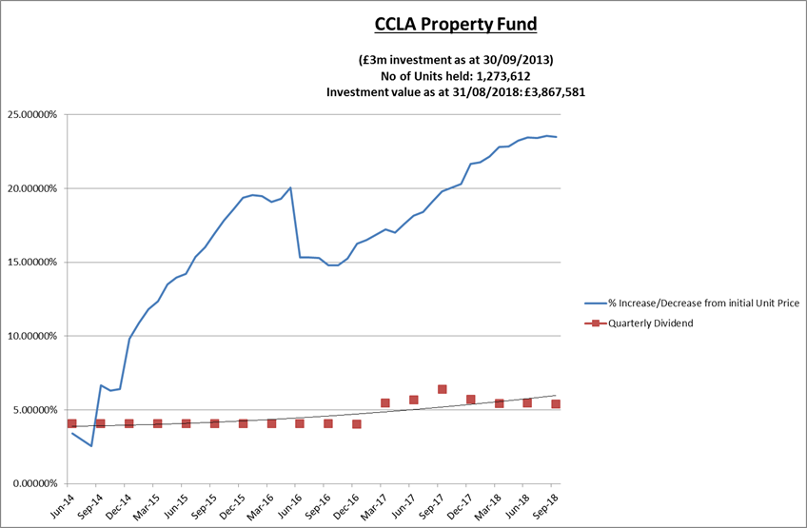
- Changes to the accounting rules on property funds means that the principal gain or loss will now be charged to the Surplus or Deficit on the Provision of Services, rather than being held on the balance sheet. However, following consultation by MHCLG the government has introduced a mandatory statutory override for local authorities to reverse out the effect for five years from 1st April 2018. Even without the statutory override, the Council would have created a reserve to hold the funds until the return was realised due to the potential for fluctuations in the property markets.
- The table below shows the gains and losses made on the fund each quarter this year (plus the figures at 31st March 2018 in order to show the opening position). It also details the quarterly dividends received. The Council holds 1,273,612 units in the Fund and the unit price is re-valued on a monthly basis, reflecting the current value of the investment (but not the interest).
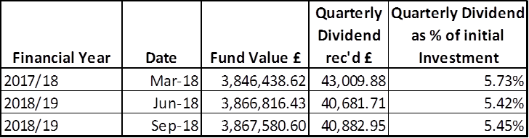
Lothbury Investment Management
- During 2014/15, the Council invested £7m in the Lothbury Property fund and the Fund has produced quarterly returns in the range of 3-4%. Furthermore, the Fund has seen a capital appreciation over the period with the value currently standing at just over £8.5m, compared with £7m at inception, equating to overall growth of 21.75% to date. However, as with CCLA, the values of the individual unit prices have fluctuated over time and the effect of capital appreciation (and depreciation) is illustrated in the graph below. The changes to accounting rules will also affect the Lothbury Property Fund as explained in paragraph 26 above.
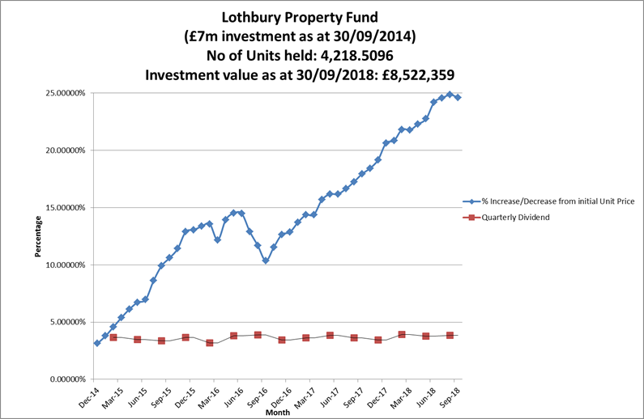
- The table below shows the gains and losses made on the Fund each quarter this year (plus the figures at 31st March 2018 in order to show the opening position) as well as the quarterly dividends received. The Council holds 4,219 units in the fund and the unit price is re-valued on a monthly basis, reflecting the current value of the investment (but not the interest).
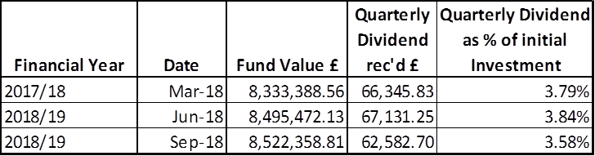
Investment Portfolio
- As at 30th September, the Council’s total investment portfolio amounted to £102.6m, with £10m of this being held in property funds and £12.1m being held in instant access cash facilities.
- The graphs below illustrate how Council’s investment portfolio is distributed, both in terms of the type of investment and counterparty category:
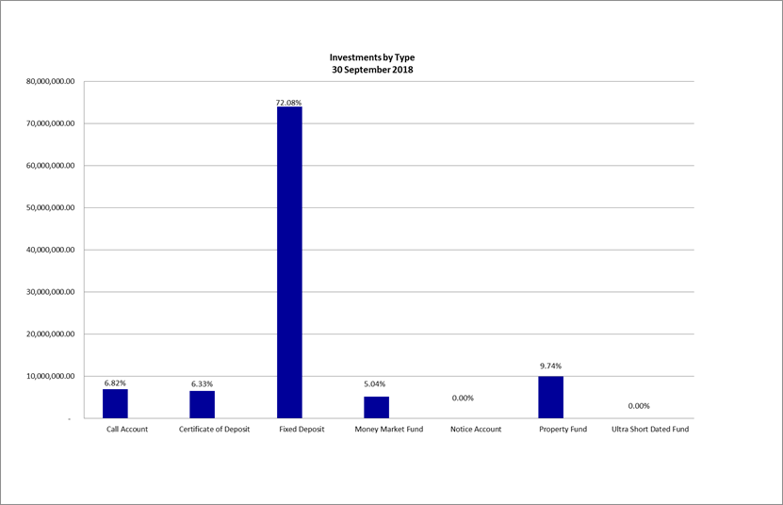
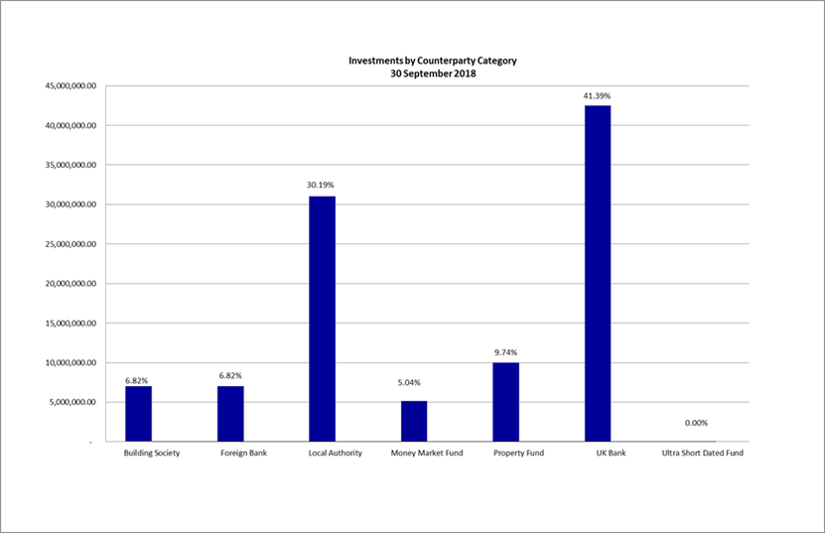
- Fixed deposits and certificates of deposits both have an agreed start and end date which are arranged where possible, to suit the cashflow requirements. However, as mentioned previously, it is also important to keep a proportion in instant access funds.
- The Council’s Treasury Management Strategy limits non-specified investments to 25% of the previous year’s average investment portfolio. This limit is reviewed each year when setting the Strategy in order to ensure a balanced and diversified portfolio of investments. Property funds and investments in excess of 364 days are classified as non-specified due to the associated risk; property funds by nature are high risk due to the volatility of the market. There are several factors that deem longer term investments to be more risky in nature including the risk of interest rate rises and the commitment of cash for longer periods.
- £10 million is committed in the CCLA and Lothbury property funds and we are currently looking at utilising residual headroom to invest further in some non-specified investments. It should be noted that the £5 million invested in the National Homelessness Property Fund (Real Lettings) is, following discussions with our external auditors, classified as a service investment undertaken using service delivery powers rather than treasury powers under Section 12 of the Local Government Act 2003.
- The Strategy defines a specified investment as one that is in sterling, no more than one year in duration or, if in excess of one year can be repaid earlier on request and with counterparties that meet the Council’s credit rating criteria. Additionally, once the duration of a non-specified investment falls below 366 days, it also falls into the Specified category. The maturity profile for the Council’s specified investments (equating to £80.5m when excluding the instant access cash) is illustrated below.
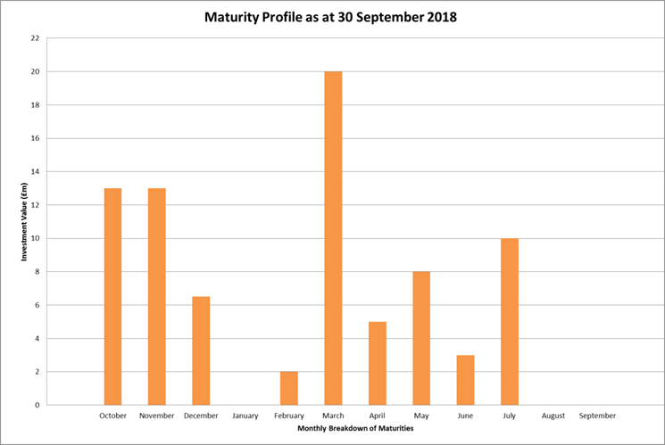
- Traditionally, the Council does not have as high an inflow of cash in February and March as it does earlier in the financial year, hence the reason for so many maturities being arranged to mature in March. It is also worth noting that the Council is limited to a duration period of six months for the majority of its approved counterparties and therefore, investments arranged in February and March would most likely mature in August and September. However, as the majority of cash income that is received towards the latter end of the financial year is accounted for within the cash flow forecasts, there is not the capacity to arrange additional investments which is why there are currently no maturities forecast for August and September 2019. Should there be a cash requirement, the Council may arrange for some short-term investments to mature in August and September but as longer investments pay a higher yield, the Council will seek to invest for longer periods where possible.
- The graph below illustrates the same investments by duration period in order to demonstrate duration periods. It is not surprising that the majority of investments have a duration period of six months as this is the limit for most of the banks and building societies with whom the Council may invest. When the opportunity arises, longer investments are arranged to allow for a greater yield.
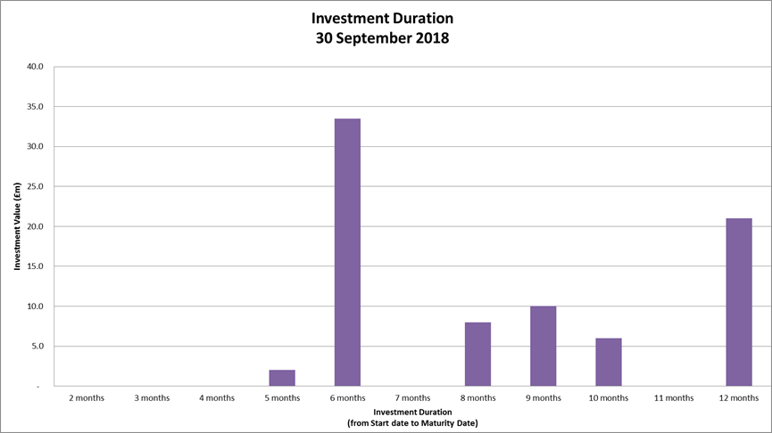
- The 2018/19 budget has allowed for £1.84m interest from investments; as at 30th September 2018, total interest earned amounted to £0.901m and a revised forecast interest suggests that the Council will earn a further £0.987m in the second half of the financial year, bringing the overall total interest to £1.88m; the variance is primarily due to the base rate rise that occurred in August.
Borrowing
- The Council has not taken on any additional debt during the year to date and so the balance of its external borrowing remains at approximately £198.5 million; this figure relates to funds borrowed from the Public Works Loans Board (PWLB) to buy out the Housing Revenue Account (HRA) from the subsidy system and relates wholly to Housing with interest repayment being met by the HRA. The Council does not consider that debt restructuring and/or premature repayment would be practical at this time as due to the differential in interest rates, the Council would incur a large premium from the PWLB for doing so. The Council continues to monitor borrowing interest rates and forecasts on a regular basis and will continue to review its position on debt restructuring.
- The Council anticipates borrowing in the future to meet its capital expenditure requirements, including loans to the Housing Company, but does not anticipate any external borrowing during 2018/19. The levels of external borrowing currently anticipated are as follows:
2019/20 £25.780 million
2020/21 £16.338 million
2021/22 £23.335 million
2022/23 £8.194 million
Treasury and Prudential Limits for 2018/19
- The Council has operated all of its Treasury Management activity within the parameters set by the Treasury and Prudential indicators in the Treasury Management Strategy for 2018/19.
Other Key Updates
Capital Strategy
- In December 2017, the Chartered Institute of Public Finance and Accountancy, (CIPFA), issued revised Prudential and Treasury Management Codes. As from 2019/20, all local authorities will be required to prepare a Capital Strategy which is intended to provide the following:
- a high-level overview of how capital expenditure, capital financing and related treasury management activity (primarily borrowing) contribute to the provision of services
- an overview of how the associated risk is managed
- the implications for future financial sustainability
- A report setting out our Capital Strategy will be taken to CEB and then Council, before 31st March 2019.
UK Banks – ring-fencing
- The largest UK banks, (those with more than £25bn of retail / Small and Medium-sized Enterprise (SME) deposits), are required, by UK law, to separate core retail banking services from their investment and international banking activities by 1st January 2019. This is known as “ring-fencing”. Whilst smaller banks with less than £25bn in deposits are exempt, they can choose to opt up. Several banks are very close to the threshold already and so may come into scope in the future regardless.
- Ring-fencing is a regulatory initiative created in response to the global financial crisis. It mandates the separation of retail and SME deposits from investment banking. In general, simpler activities offered from within a ring-fenced bank, (RFB), will be focused on lower risk, day-to-day core transactions, whilst more complex and “riskier” activities are required to be housed in a separate entity, a non-ring-fenced bank, (NRFB). This is intended to ensure that an entity’s core activities are not adversely affected by the acts or omissions of other members of its group and that the risks inherent in investment banking are removed from the retail customers.
- While the structure of the banks included within this process may have changed, the fundamentals of credit assessment have not. The Council will continue to assess the new-formed entities in the same way that it does others and those with sufficiently high ratings will be considered for investment purposes.
Markets in Financial Instruments Directive (MiFID) II
- Under the MiFID directive, local authorities must be categorised as ‘retail’ clients, with the ability to opt-up to elective professional client status should it have a business requirement to do so. MiFID II was implemented in January 2018 and the Council did indeed opt up to professional status; had the Council continued to be classified as a retail client after this date, it would have extremely limited access to the money markets as several of the approved counterparties, including the property funds, money market funds, brokers and indeed the Council’s own treasury advisors, stipulated that their clients must be classified as “professional” under the new directive.
- In order to ‘opt up’ from a retail client to an elective professional client, the Council had to fulfil several quantitative and qualitative criteria as prescribed by the Financial Conduct Authority in relation to its business as a local public authority or municipality (“Treasury Business”).
- As part of the process, the Treasury Manager had to provide evidence that all officers with Treasury responsibilities have the necessary expertise, experience and knowledge to conduct transactions envisaged in the respective markets; that the officers understand the nature of the risks involved with Treasury transactions and that
- The Council also had to fulfil the following criteria:
- That over 4 quarters prior to January 2018, it had conducted an average of 10 transactions per quarter, in significant size, on the relevant market; or
- That the persons undertaking the transactions work or have worked in the financial sector for at least one year in a professional position, requiring knowledge of the provision of services envisaged; or
- The authority is an ‘administering authority’ of the Local Government Pension Scheme
- Oxford City Council fulfilled and continues to fulfil the first two requirements; it is exempt from the third criterion.
- As part of the “opting up” process, the Section 151 Officer had to sign a declaration acknowledging that being categorised as a Professional Client means that the Council will not benefit from the protections and investor compensation rights; the loss of these protections and rights were carefully considered and advice was sought from Link Asset Services.
IFRS 9 Accounting Standard
- This accounting standard came into effect from 1st April 2018. One of the changes means that the category of investments valued under the available for sale category will be removed and any potential fluctuations in market valuations will impact on the Surplus or Deficit on the Provision of Services, rather than being held on the balance sheet. This change is unlikely to materially affect the commonly used types of treasury management investments but more specialist types of investments (e.g. pooled funds, third party loans, commercial investments) are likely to be impacted. Following the consultation undertaken by MHCLG on IFRS9 the government has introduced a mandatory statutory override for local authorities to reverse out all unrealised fair value movements resulting from pooled investment funds. This will be effective from this financial year, 1 April 2018. The statutory override applies for five years from this date. Local Authorities are required to disclose the net impact of the unrealised fair value movements in a separate unusable reserve throughout the duration of the override in order for the Government to keep the override under review and to maintain a form of transparency.
- The other major effect of this accounting standard is to require authorities to make a provision for the loss of its investments based on an assessed risk. Where provision is necessary, this cost will also be charged to the Surplus or Deficit on the Provision of Services, however the impact of this is also subject to the statutory override for 5 years following the MHCLG consultation.
Changes in Risk Appetite
- The 2018 CIPFA Codes and guidance notes have placed enhanced importance on risk management. Where an authority changes its risk appetite e.g. for moving surplus cash into or out of certain types of investment funds or other types of investment instruments, this change in risk appetite and policy should be brought to members’ attention in treasury management update reports. Oxford City Council has not made any significant changes to its investment approach at this time although there is the intention to further invest in property funds in the near future. The risk will continue to be managed by through understanding the individual investment vehicles and also by considering the appropriate percentage of non-specified investments that can be held in the overall portfolio.

Treasury Advisor
- Treasury advice and market information is provided by Link Asset Services, formerly known as Capita Asset Services. The contract for Treasury Advisors was extended for two years in September 2016 and was due for retendering in September 2018. The tender process has completed and Link Asset Services have again be awarded the Treasury Advisor contract for 3 years with an option to extend for a further 2. Information provided by Link Asset Services is used to advise Council Officers when making investment decisions.

Financial Implications
- Any financial implications are contained within the body of this report.

Legal Issues
- There are no legal implications directly relevant to this report.

Level of Risk
- There are no risks in connection with the report’s recommendations. Risk assessment and management is a key part of Treasury Management activity especially in the selection of counterparties when considering investment opportunities. The Council uses external advisors and counterparty credit ratings issued by the rating agencies to assist in this process.

Equalities Impact
- There are no equalities impacts arising directly from this report.

Report author | Bill Lewis
Job title | Financial Accounting Manager
Service area or department | Financial Services
Telephone | 01865 252607
e-mail | blewis@oxford.gov.uk

Background Papers: None

